Explain batch file

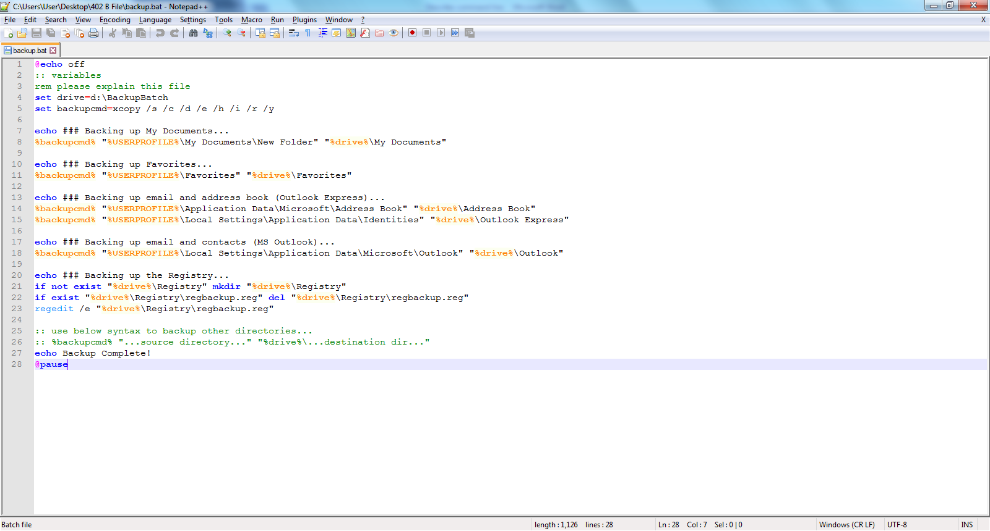

1. turn off command display
2. ::function is remarks the variable
3. Remake the word
4. Set drive as a variable to d: after that go backupbatch folder
5. Set the “backupcmd” as a variable command and the command function is “xcopy”, that include “/s /c /d /e /h /i /r /y”.
6. Empty
7. Display message
8. The %backupcmd% is xcopy /s /c /d /e /h /I /r/y and path is user profile\my documents\new folder and copy to drive\my document

21 if not exist registry create a new

22 if exist regback.reg delete the regbackup.reg

23 Export the registry file

Task c

Mail server – recommend . 免费很多设置 -way auto reply -problem 接受不到 网络问题 -solution -cable

Correct spelling – 避免错误 - way - problem 打字错误 -right

Click

Back up – 备份和resotre – 哪里设置 – 内存不足 -确定内存

Software updates on start up – 可以避免incompatible 和 virus – way -通过哪里可以更新 problem – configure 问题 – 检查网络和通过msconfig